|  |  |  |  |  |  |
| --- | --- | --- | --- | --- | --- |
| Date | September 20, 2022 | | | Tester Name | Alyssa Johnson |
| Environment | Penfax - Test | | | Login used |  |
| Operating System | Select OS | Version: | Update: | | |
| Software Used | Select Software | Version: | Update: | | |
| Select Software | Version: | Update: | | |
| Release version | 22.3.0 | | | | |
| Title | E23.07 | | | | |
| Test Type | Regression | | | | |
| Test Scenario | Process PEPP Welcome Letters | | | | |
|  |  | | | | |
| Expected Results | * Verify the member was enrolled in PEPP * Confirm batch run successfully * Confirm letters generated and saved on member communications and visible on PLANet member (with the correct name) * Confirm that no welcome letter generates for any re-enrollments (eg. Funds are still here and they re-enroll with any PEPP employer). | | | | |
| Pass/Fail | Pass | | | JIRA# | N/A |

Process several enrollments from ER PlaNet & one manual enrollment on Penfax.

Requested some enrollment files for 0050 from business & uploaded files:

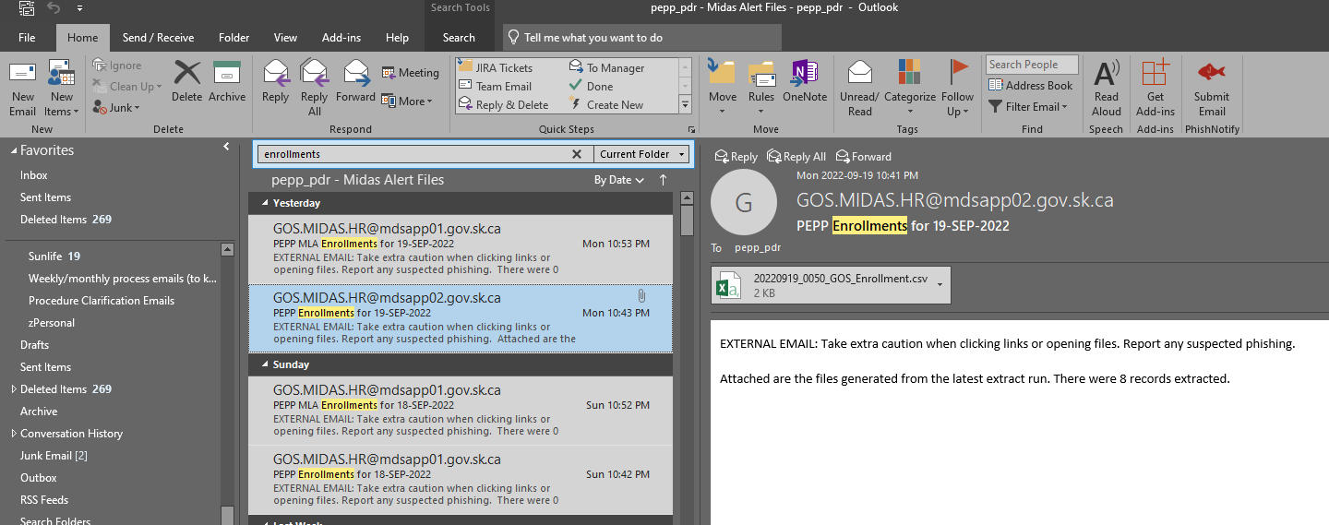

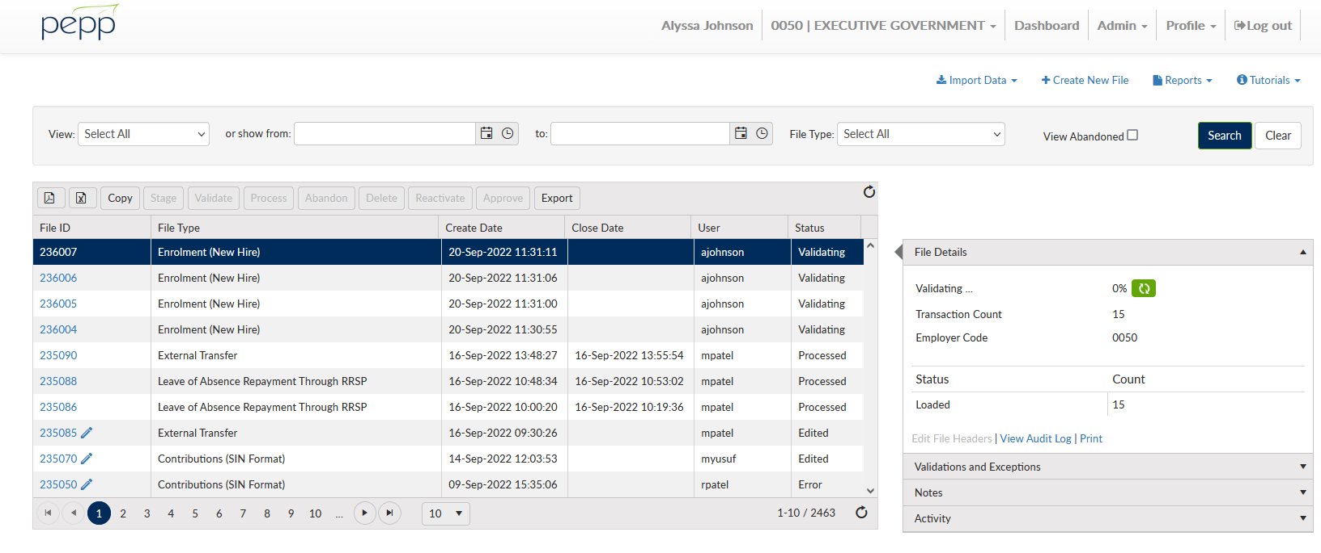

Override and fix any errors/invalid entries:

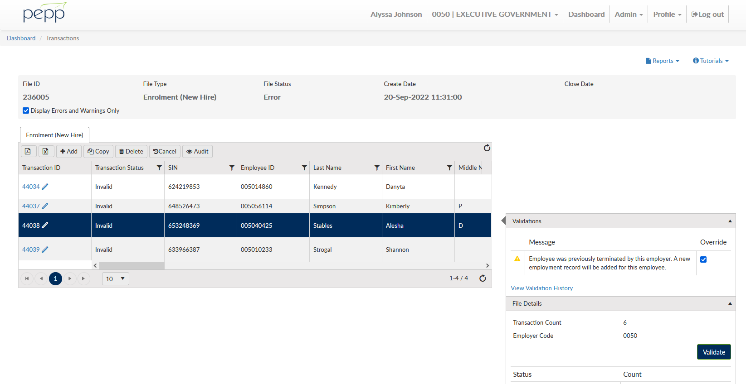

*changed one to a USA address to confirm out of country letters.

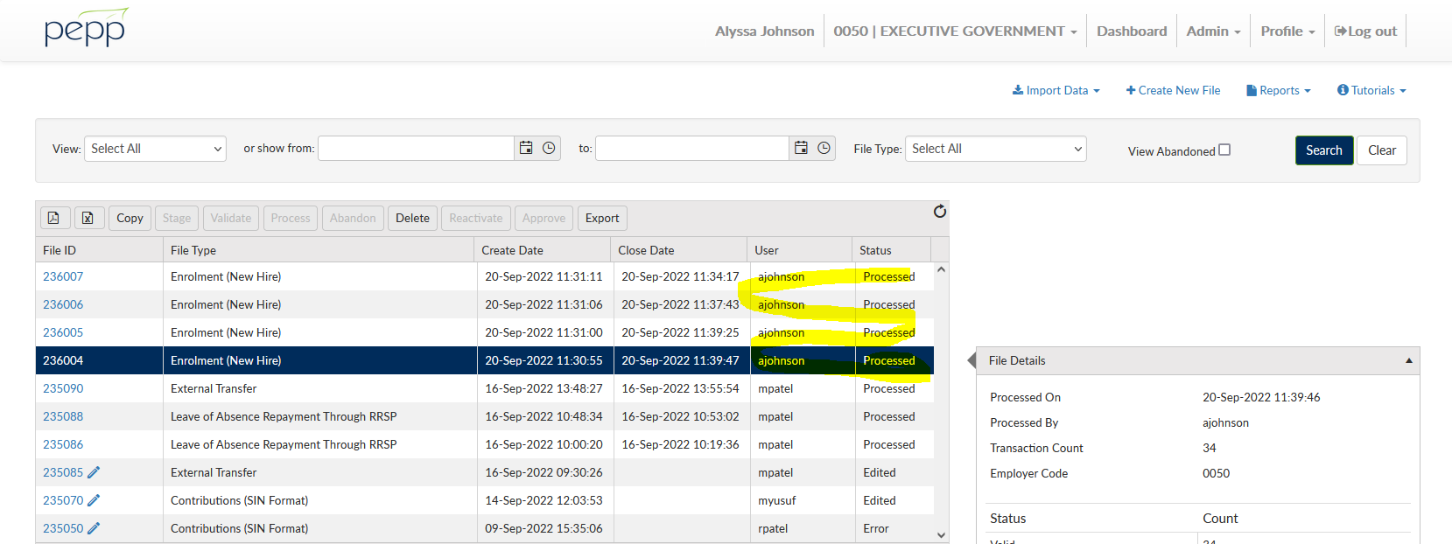

Then press process & do the Penfax side of the enrollments:

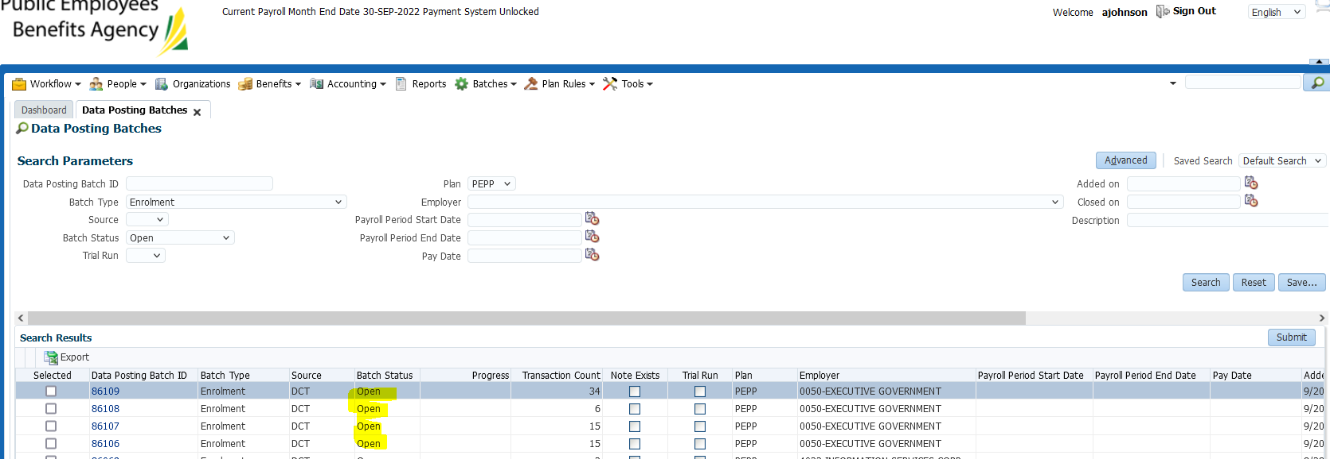

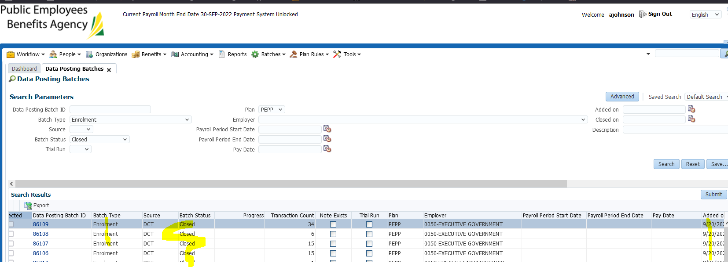

SID:214324 - Manually Re-enrolled

Go to employee profile and click add:

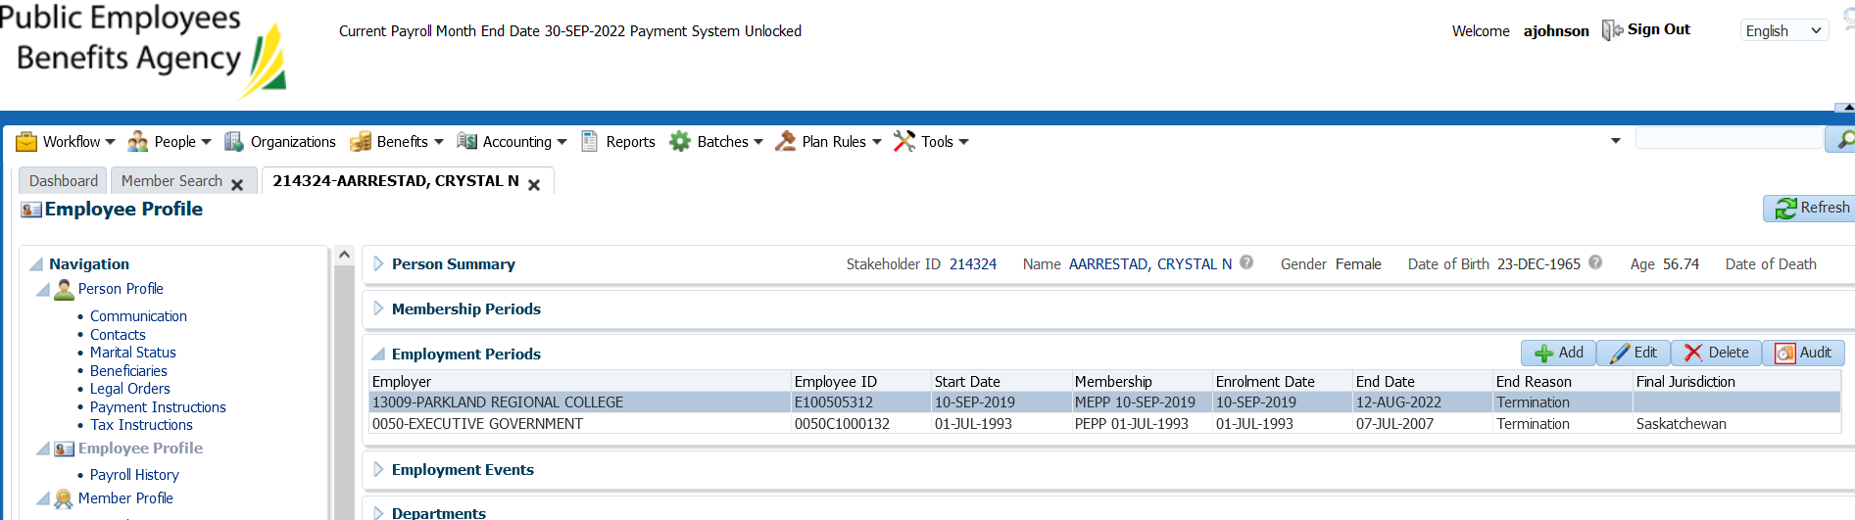

Fill in information below & click save:

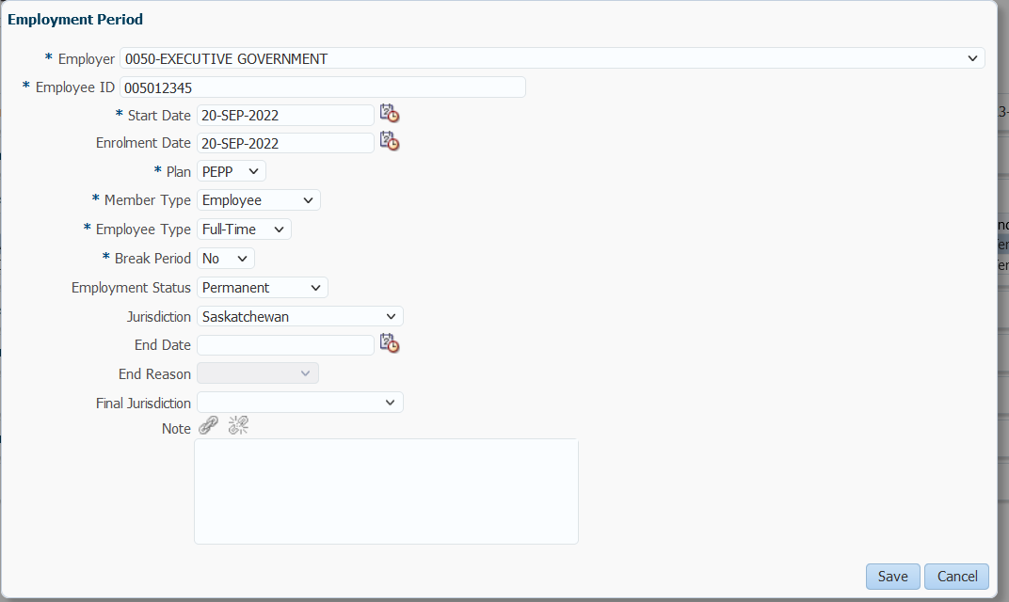

Confirm member profile is set to active (was previously deferred):

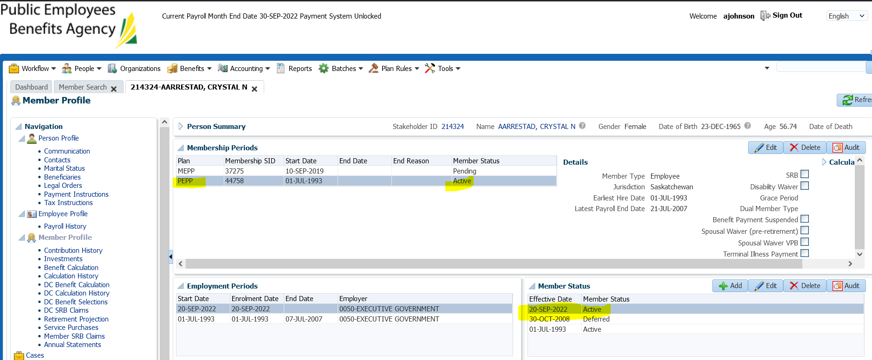

SID: 485357 - New Member added manually

Open person search and click “add person”:

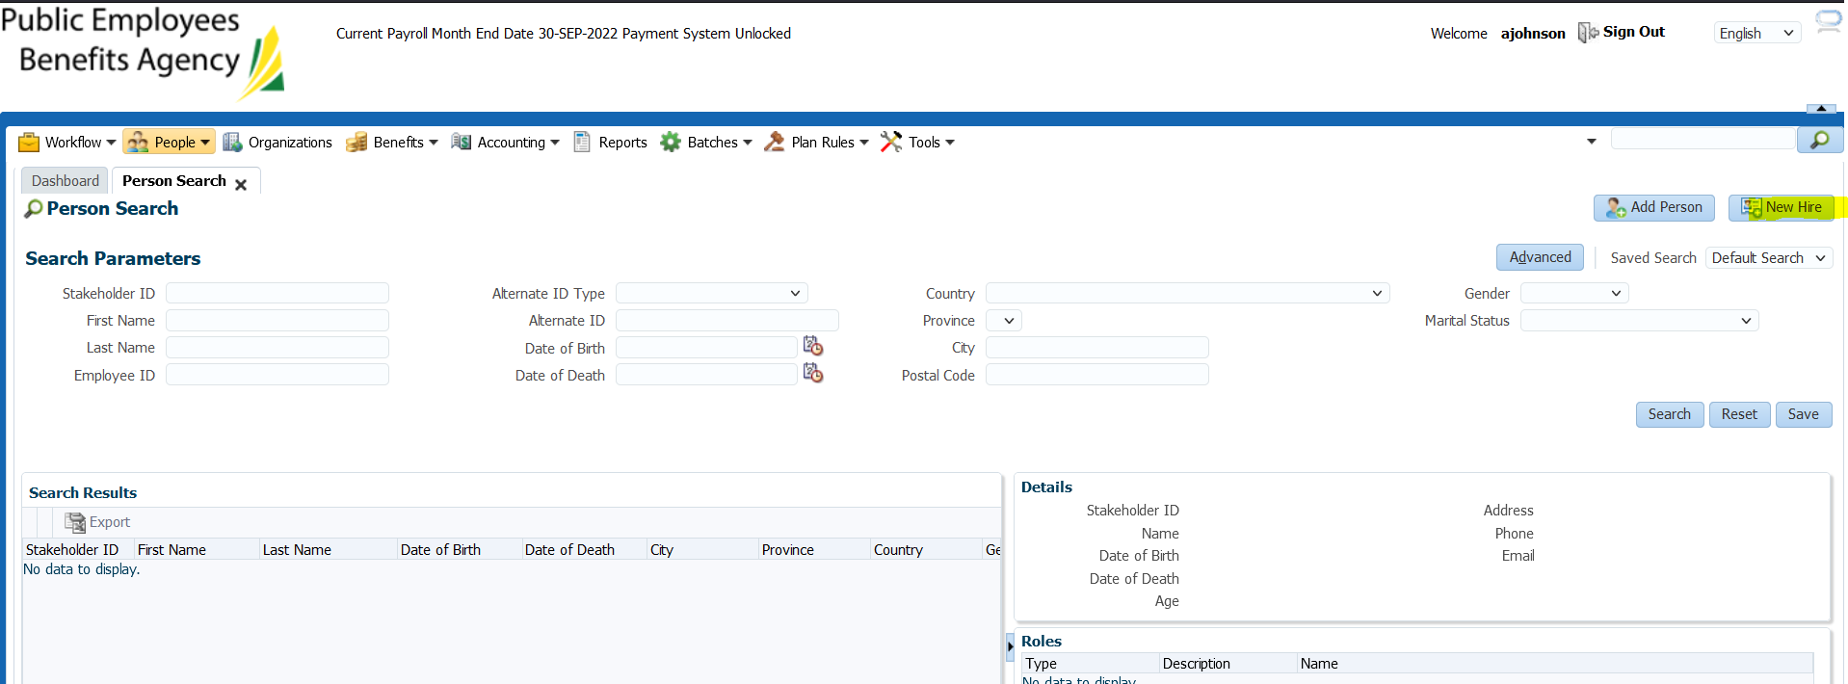

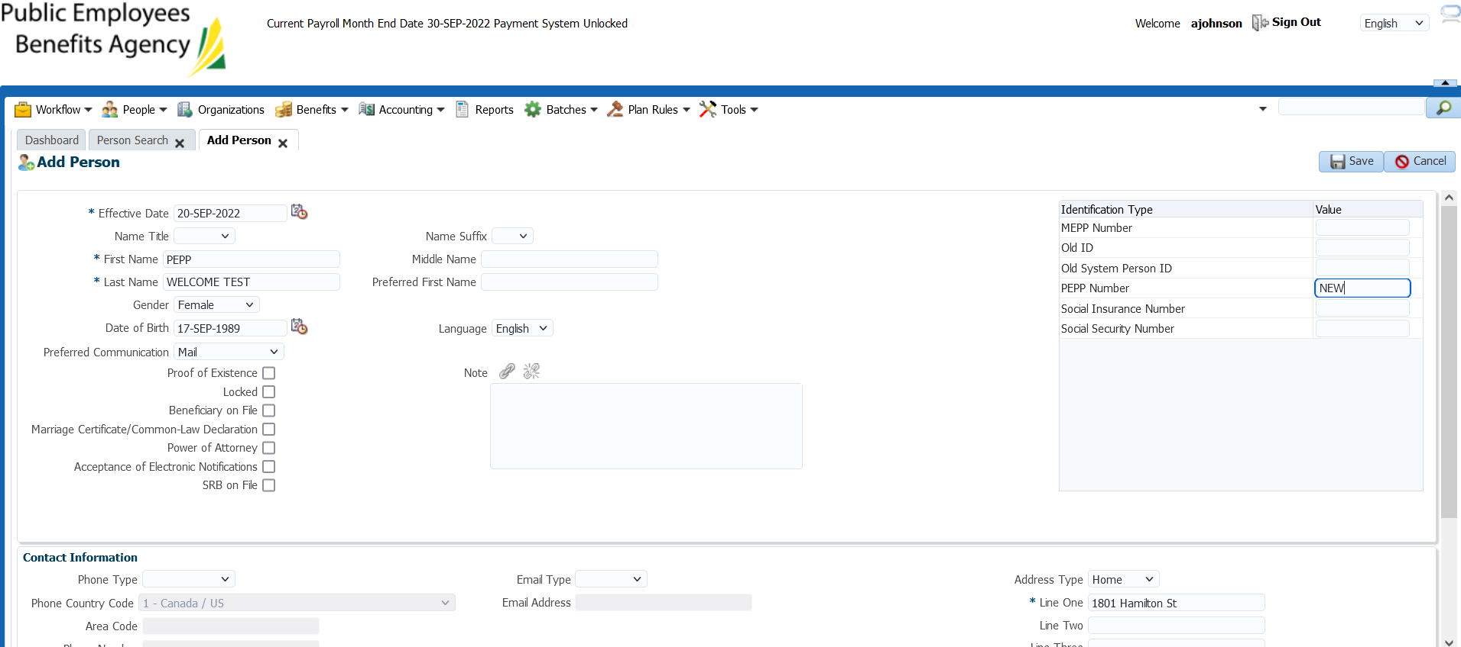

Now click New Hire to add ER details:

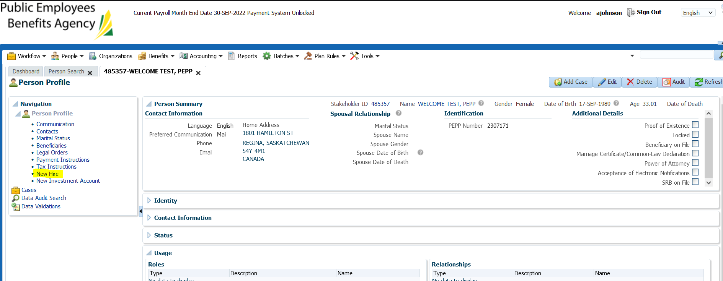

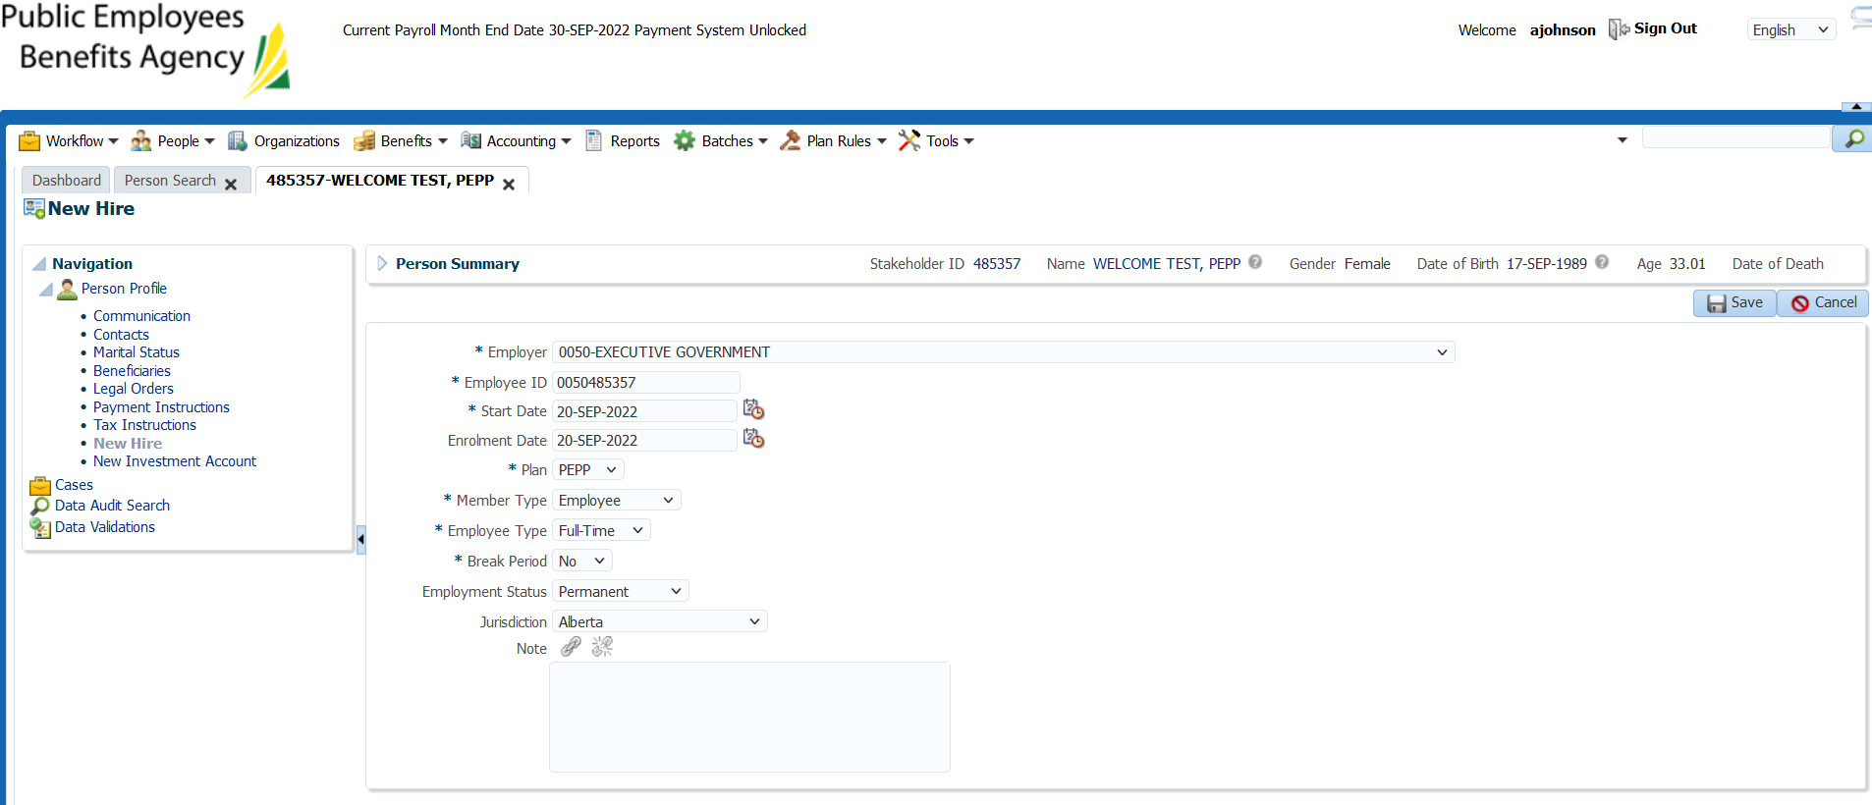

Investment account automatically populates after the new hire step. Enrollment complete.

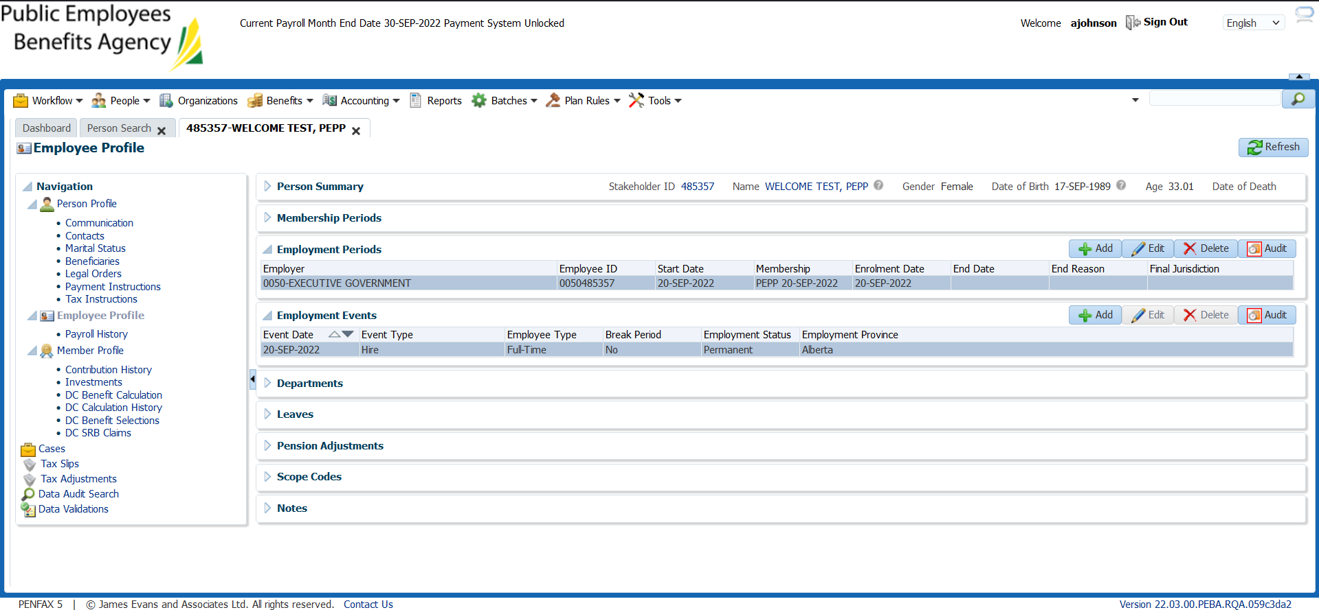

Check back tomorrow to confirm welcome letters generated (72 letters total minus any re-enrollments expected)

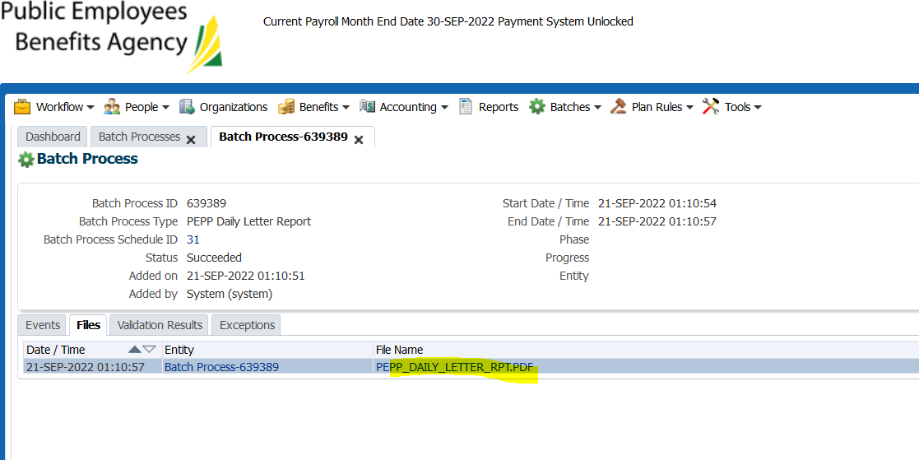

51 letters generated.

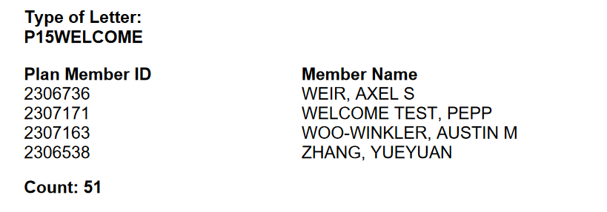

Confirmed that there were 21 re-enrollments, re-enrollments are not supposed to get welcome letters. Spot checked and that accounts for the letters that are missing.

Tested the manual re-enrollment and no welcome letter generated:

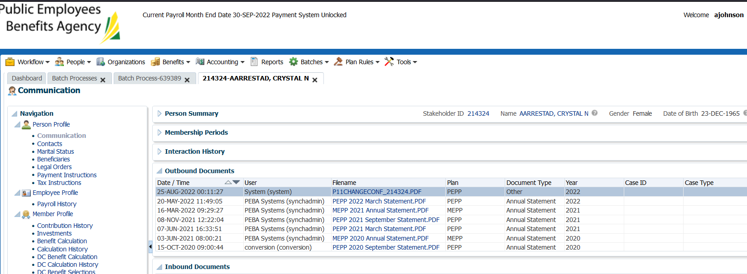

Confirm view on PlaNet & communications tab:

SID 485290

